Lab 2

Web

Joshua Beaulieu

Part 1

|  |  |  |  |  |  |  |  |  |  |  |  |  |  |  |
| --- | --- | --- | --- | --- | --- | --- | --- | --- | --- | --- | --- | --- | --- | --- |
| Q1 | Q2 | Q3 | Q4 | Q5 | Q6 | Q7 | Q8 | Q9 | Q10 | Q11 | Q12 | Q13 | Q14 | Q15 |
| b | a | a | a | b | b | d | b | c | b | d | a | c | b | a |

Part 2

|  |  |  |  |  |  |  |  |  |  |  |  |  |  |  |
| --- | --- | --- | --- | --- | --- | --- | --- | --- | --- | --- | --- | --- | --- | --- |
| Q1 | Q2 | Q3 | Q4 | Q5 | Q6 | Q7 | Q8 | Q9 | Q10 | Q11 | Q12 | Q13 | Q14 | Q15 |
| b | a | a | b | a | b | a | b | a | b | a | a | a | b | a |

Part 3

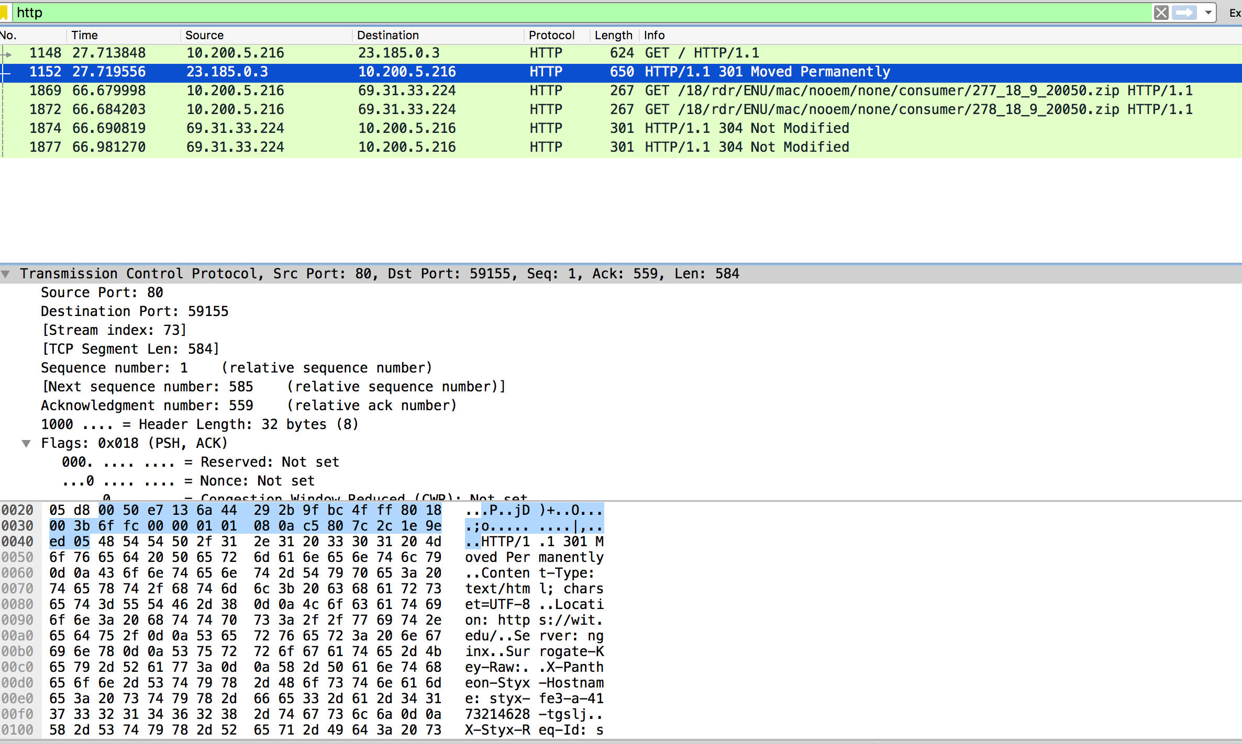

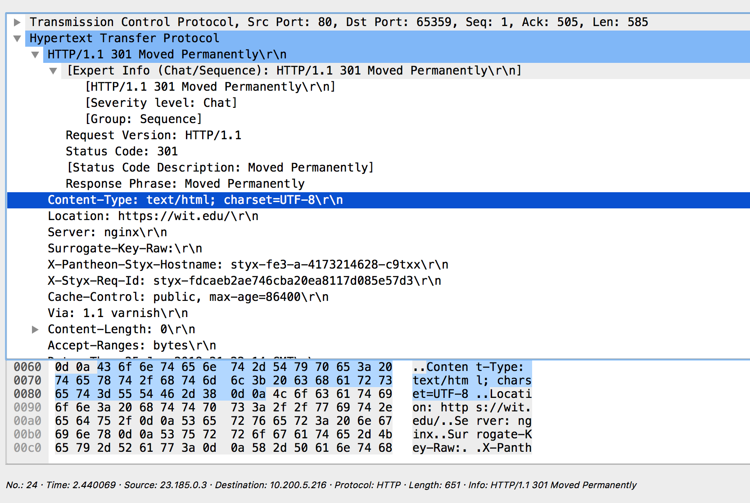

This HTTP packet Moved Permanently means when you go to wit.edu it redirects you to a new permanent URL. It makes you go to another location when you try to go to wit.edu so you end up at the new location.

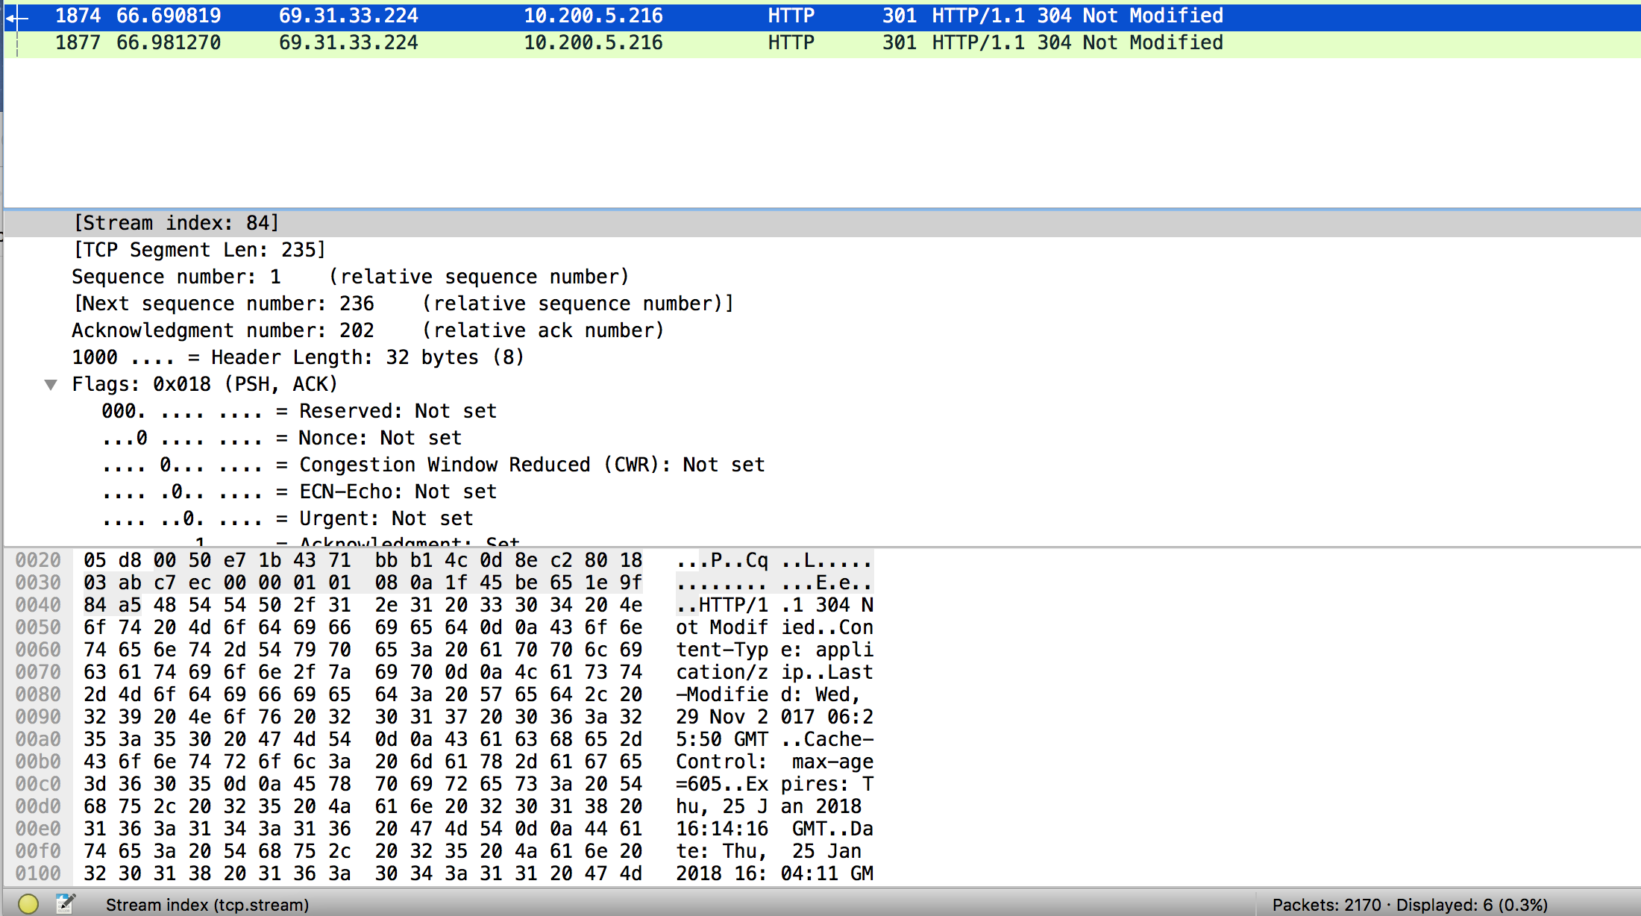

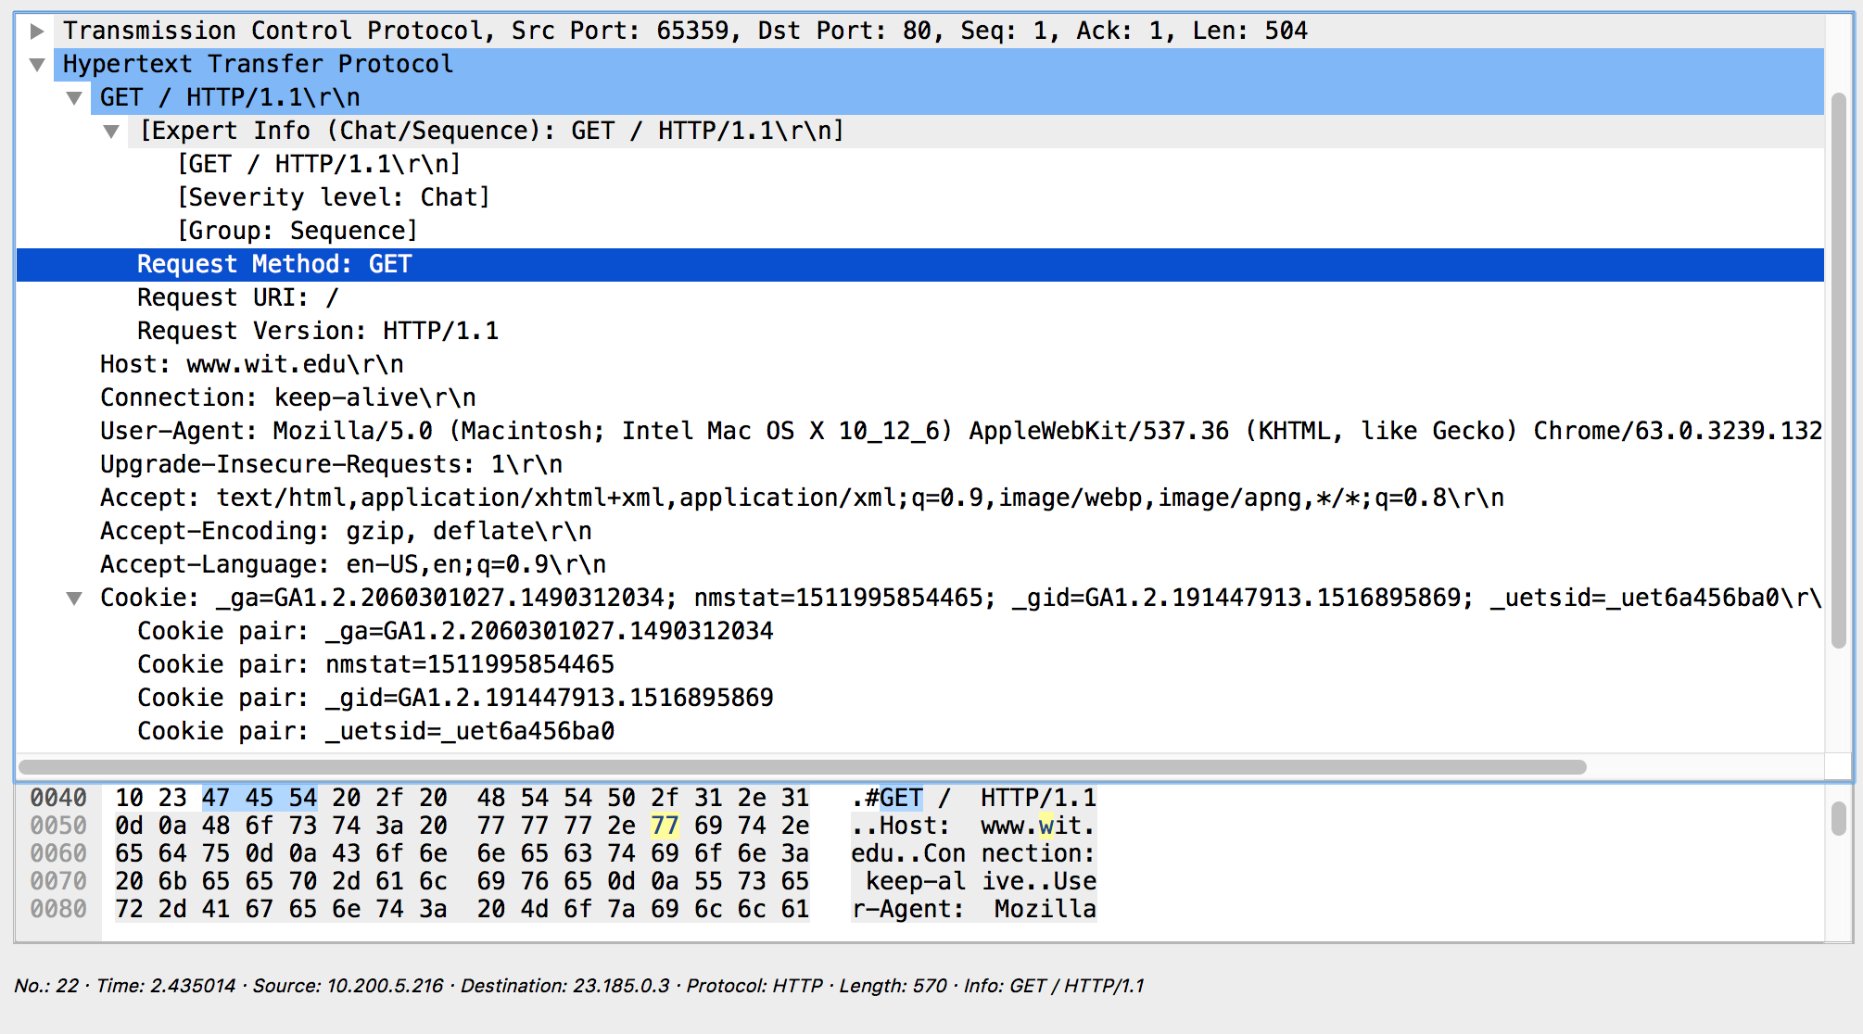

This HTTP packet returns to the client if the cached copy file is up to date with the server. The client performed a get request and the access was allowed but the document was not modified so the request is terminated by the empty header.